|  |  |  |
| --- | --- | --- |
| A close up of a logo  Description generated with very high confidence |  | |
| Implement safer way to share message center posts | |
|  | PM: Jon Orton  Design: Leyla Jafarli  SWEs: Lakshita Sharma (Lex)  Angel Seiji Morimoto Burgos |

## Overview

We will institute a new Sharing feature in the Message Center to replace the one that had to be deactivated due to abuse.

**Background**

For several years, Message Center posts had a Share button that allowed admins to share the content of the post via email, with an option to add a custom note. In November 2024, the API behind this feature was used by bad actors to send sextortion emails originating from a Microsoft email address. We disabled the feature and reverted to a basic sharing experience that uses the mailto: command to launch the user’s default mail client and populates an email with plain-text, truncated content.

This inferior sharing experience has received customer complaints because it does not share the full details of the post or include key elements like images. Examples: [586652945 - IcM](https://portal.microsofticm.com/imp/v5/incidents/details/586652945/summary) and [595565230 - IcM](https://portal.microsofticm.com/imp/v5/incidents/details/595565230/summary).

## Business Justification

A common part of our customers’ change management workflow is to notify others or delegate work to them. The prior share function allowed customers to do this in an elegant way. The new experience is clunky and incomplete. By restoring the ability to share the entire content of a post with rich formatting, in a way that prevents abuse, we reduce the overall effort required for customers to manage change in their organizations.

## Scenarios

**An admin shares the content of a message center post**

An administrator working in the Microsoft 365 admin center views the details of an upcoming change to Teams. She wants to share this information with the person in her organization that handles user training. This person does not have access to the admin center.

She clicks the Share button.

A sharing screen lets her choose the recipients of the message, defaulting to the primary email address on file for her.

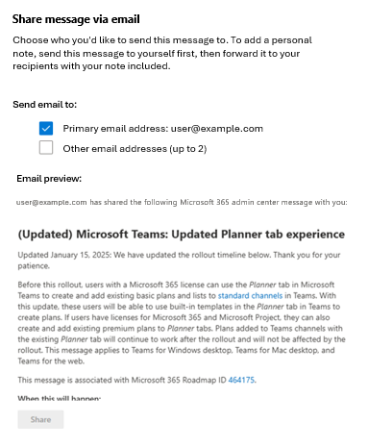  
If the user clicks the ”Other email addresses” checkbox that section expands to this:  
  
 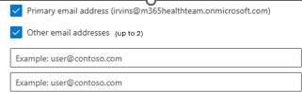  
  
(this checkbox behavior should match what is in place on the Service health page --> Customize --> Email --> Send me notifications about service health)  
  
Note: Because of the simplicity of these changes, we have mocked up the new UI in PowerPoint rather than Figma. Use standard font and font sizes even though the new text in PowerPoint doesn‘t exactly match the existing UI. The strings in these mockups have been finalized by our content designer: [Visual aids for MC sharing spec.pptx](https://microsoft-my.sharepoint-df.com/:p:/p/jonorton/Eadofx3MRsZMnoupqYz0Y1MBzTQR2cNYnqpCl4wzgwINpw?e=zy0JuL)

When the admin clicks Share, an email is sent to the specified recipients.

Note: If the admin clicks the “other email addresses” checkbox, two email address input fields are shown:

## Functional Requirements

* This spec does not outline all aspects of the Share experience (such as the full format of the email sent, or the success screen UI. The former behaviors of the prior Sharing function will be restored, except the ability to add a personal note.

## API Updates Needed

The API supporting this feature, managed by the SCP team, has been deactivated, so it will need to be reactivated. As part of this reactivation, we need to:

* Remove the custom message field from the API (required)
* Limit recipients to up to three valid email addresses (highly desired)
* Implementing rate limiting monitoring for one account sending many emails within a short period of time (optional –could be pushed to depending on results of technical exploration)

## Measurement

As part of implementing this feature, we need to ensure that our usage dashboards housed at <https://aka.ms/screports> include measurement of the correct usage of this feature. This *sharingemailsentheretextfield* action count in the Message Center à Admin center usage dashboard à MC report seems like it may track the number of sharing actions.

This indicator showed 145k actions in August 2024 (none in recent months because we deactivated the feature. Let’s check the code to determine exactly what is being measured.

## Goals

* Restore the ability to share the *full* content of a message center post with images, etc (not truncated plain text)
* Do not introduce vulnerabilities that would allow bad actors to use our email platform to send malicious content
* Accomplish these outcomes with minimal engineering work

## Partners and Dependencies

* SCP team – to coordinate reactivation of API and any necessary hardening. Start with Angel Seiji Morimoto Burgos

## For consideration in a future release

These ideas were surfaced in the spec review but will be placed on the backlog rather than included in this release:

* Prompt users with a list of most recently used email addresses in the sharing box
* Show sharing history for the MC post so admins can avoid sending duplicates

**Alternatives Considered But Not Selected**

*Copy to clipboard:* The service health page includes a Copy text button that copies the text of a service incident to the user’s clipboard for easy sharing. However, this does not preserve formatting or images in an acceptable way.

*Use AI summary:*  The fact the content is truncated seems to be the source of user frustration (“Content truncated due to character limitations” is the first line. We could keep the mailto: approach of sending email and populate the email with the AI summarized version of the content, eliminating the need for truncation. However, this does not allow non-admins to access the full version of the content, which is the logical next step after viewing the summary.

*Send only to self:* Limiting email sharing to the primary address on file would make the UI simpler and have less security considerations, but many enterprise admins use a separate M365 account for administration. This account is not the one where they receive email and is often not licensed at all.

**Appendix**

Previous Share experience (now deactivated)

Email signup experience on Service Health page:

Email signup experience on Message Center Page:

Our understanding of the reasons that customers have used the Share button:

1. Someone in their organization can’t access the admin center; so this is the best way to deliver info about the change to them
2. They want to assign the item to someone in the organization and start an internal conversation about it “hey you need to do something about this…”
3. As a reminder to themself to act